Laundry Reflection

- Was this the first load of laundry you have washed? ________________________________
- How long did it take you to complete one load of laundry? From the time you started sorting, until the time you finished folding. _______________________________________________
- Did you find it easy? Why or why not? ____________________________________________________________________________________________________________________________________________________________________________________
- Is laundry something you are going to continue doing on a regular basis?
If no, why not?
________________________________________________________________________________________________________________________________________________________________________________________________________________________________________________

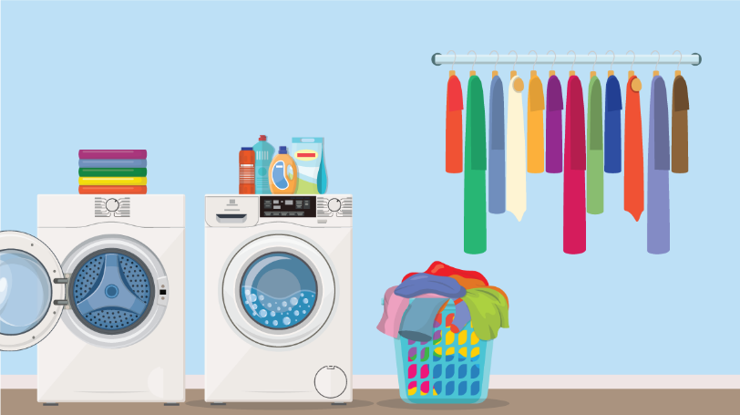

Please send a picture of the folded load of laundry to lmcfadyen@lssd.ca or simply have a parent sign.

Student’s name: __________________
Parent/guardian’s signature: _______________________

